TEMPLATE FOR SHORT BIOGRAPHY OF SPEAKERS FOR BALKANS JOINT CONFERENCE
Please use this template to submit your short biography, which will be uploaded on the Conference Website
The photo must be in JPEG and submitted separately. Please in the max size 600px x 431px
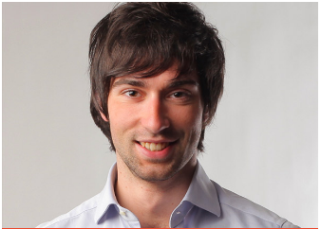  NAME SURNAME  Current work position  Headshot (max size 600px x 431px)  Active Social Media, e.g Linkedin. Google etc  E-mail: contact@goodlayerswp.com | Short biography (main expertise, key qualifications and skills etc.). Biography up to 150 words  Name and Surname has over nine years of experience in sustainable development and water issues. He graduated with a Master’s degree in Environmental Engineering from the University of Arkansas, USA in 2005. He gained experience in environmental soil science, renewable resources management, waste management and pollution. Name built skills in strategic communication and outreach, web development, social media, information and knowledge management, and focused his efforts on communicating and raising awareness of sustainable development issues.  Currently, he works as a Communications Officer in the Governance Project and in the Water Division in the Ministry of Infrastructure in Albania.

